Azure Cloud

**Aim**: - Create a virtual network (Vnet), peering Vnets and private DNS zone, add virtual network link and associate public and private IP address to vm’s in the Azure portal.

Create a virtual network (Vnet) in the Azure portal

To create a virtual network using the Azure portal and deploy three virtual machines (VMs). Next, you securely communicate between VMs and connect to VMs from the internet and to peering connect between 2 vnets and connected two different regions Vms.

To create private DNS zone and add virtual network link in azure portal. Associated private and public IP address to vm’s.

1. Sign in to Azure

2. [Create virtual machine](https://learn.microsoft.com/en-us/azure/virtual-machines/linux/quick-create-portal?tabs=ubuntu#create-virtual-machine)

3. [Connect to virtual machine](https://learn.microsoft.com/en-us/azure/virtual-machines/linux/quick-create-portal?tabs=ubuntu#connect-to-virtual-machine)

4. Create a Virtual network (Vnet)

5. Create a private DNS zone and add virtual network link

1. Sign in to Azure

Log in to the Azure portal at [https://portal.azure.com](https://portal.azure.com/).

2. [Create virtual machine](https://learn.microsoft.com/en-us/azure/virtual-machines/linux/quick-create-portal?tabs=ubuntu" \l "create-virtual-machine)

Creates three Linux servers (appserver and dbserver and vm1) Vms in Azure portal.

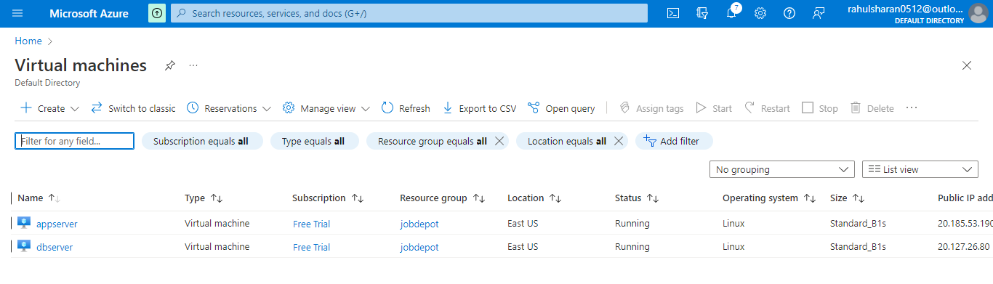

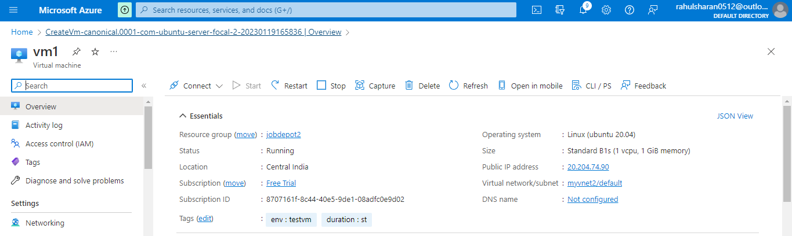

3. [Connect to virtual machine](https://learn.microsoft.com/en-us/azure/virtual-machines/linux/quick-create-portal?tabs=ubuntu#connect-to-virtual-machine)

By using SSH inbound port to connect Vms.

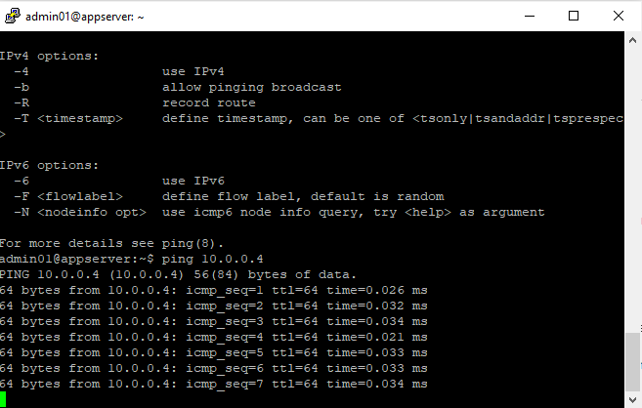

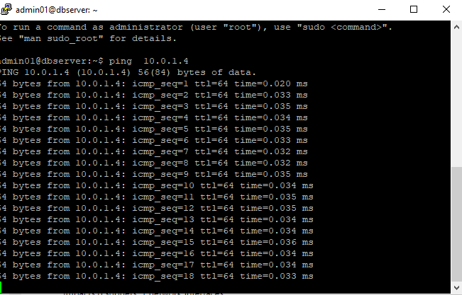

4. Create a virtual network (Vnet)

Create a virtual network (Vnet) in US east region, All services->virtual network->.

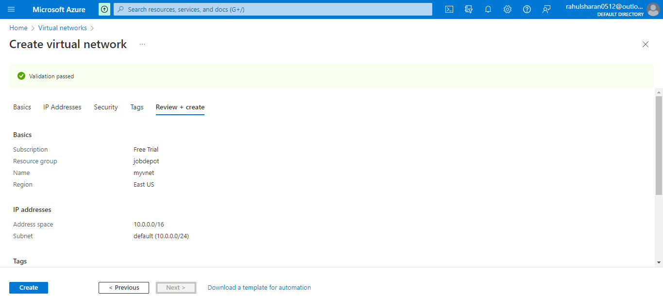

Successfully created the [virtual](https://learn.microsoft.com/en-us/azure/virtual-machines/linux/quick-create-portal?tabs=ubuntu#connect-to-virtual-machine) network (Vnet).

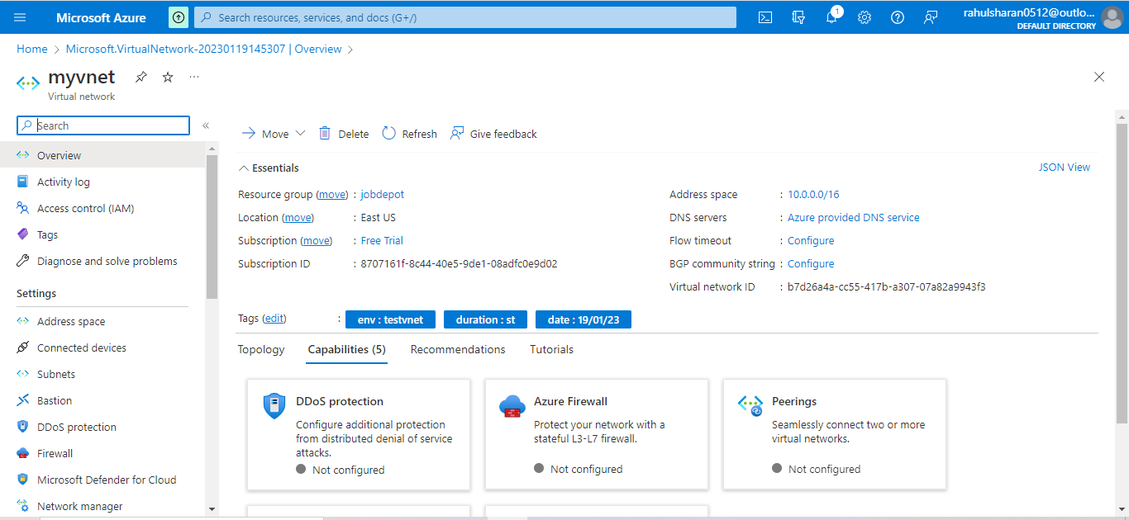

Created two subnets public-subnet and private-subnets in [virtual](https://learn.microsoft.com/en-us/azure/virtual-machines/linux/quick-create-portal?tabs=ubuntu#connect-to-virtual-machine) network.

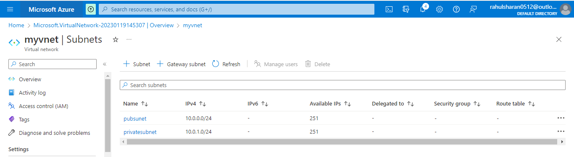

Ping from app-server to db-server using private ip.

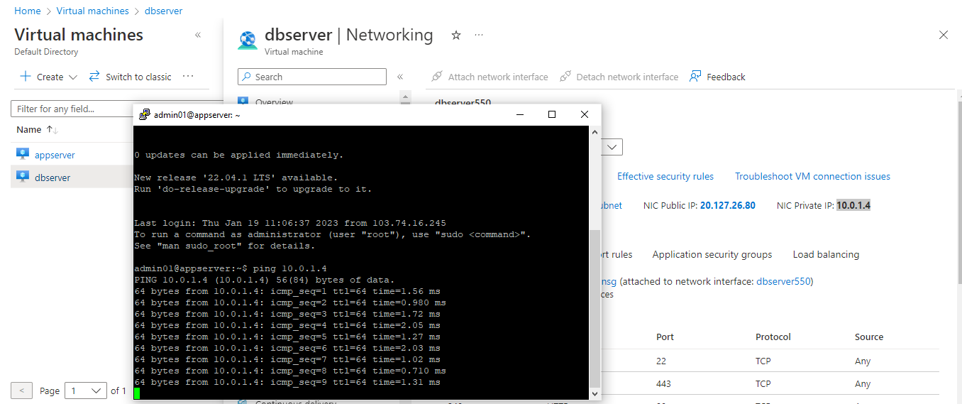

Create new virtual network (Vnet) in central India region.

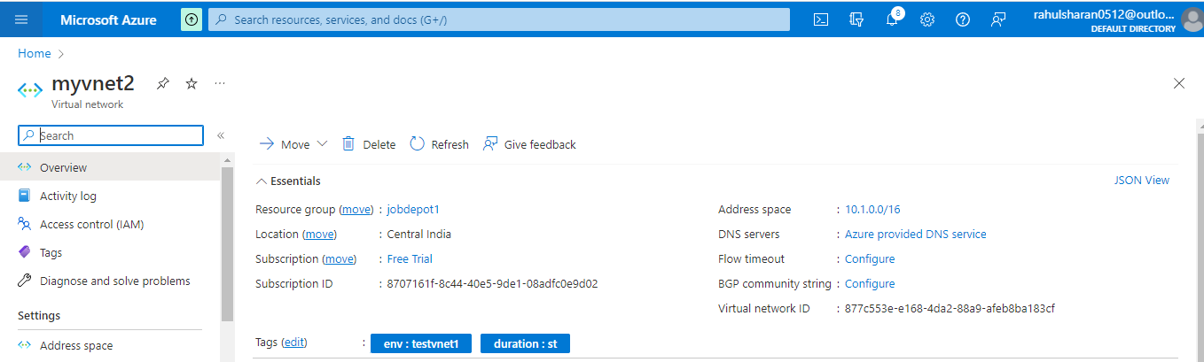

Create a peering connect between 2 Vnets.

Virtual network->myvnet(US east)->peering->add peering(useast to indiacentral).

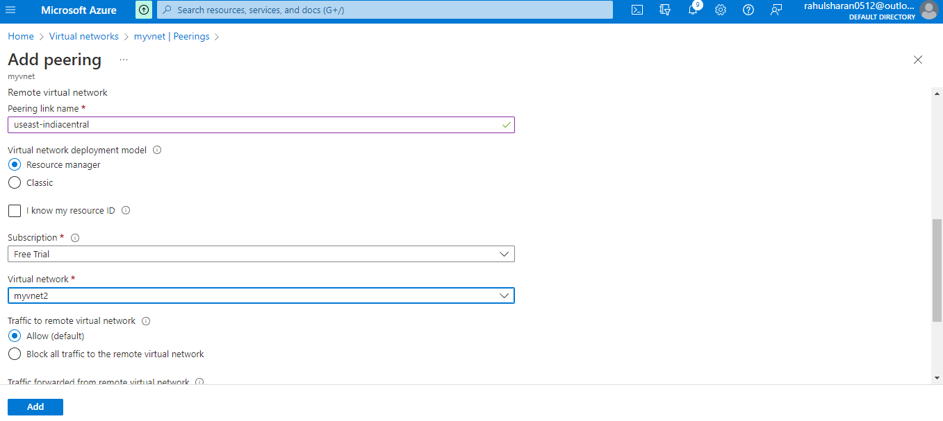

Successfully added the USEast and IndiaCentral peering.

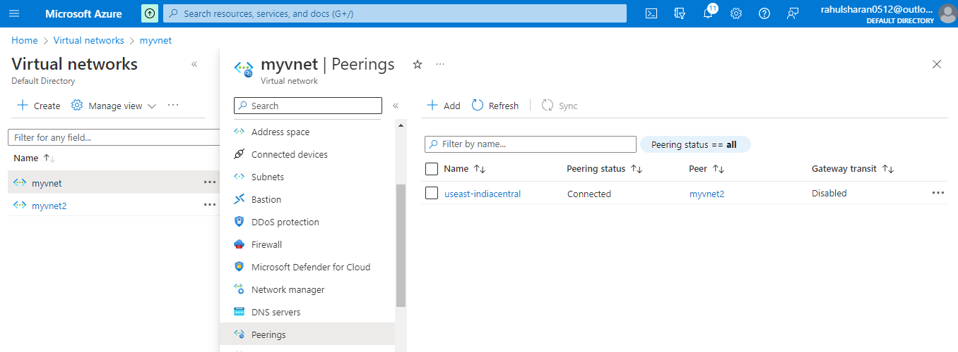

Ping from vm (vm1) Central India region to Vms (appserver and db server) in EASTUS using private ip.

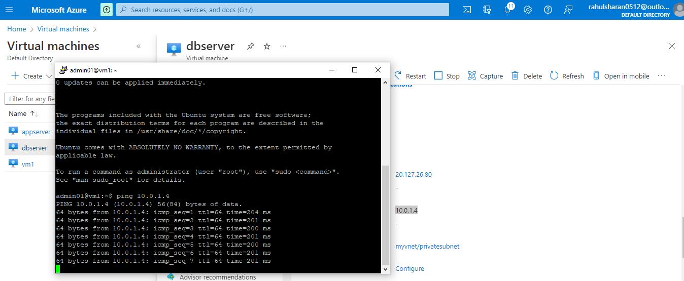

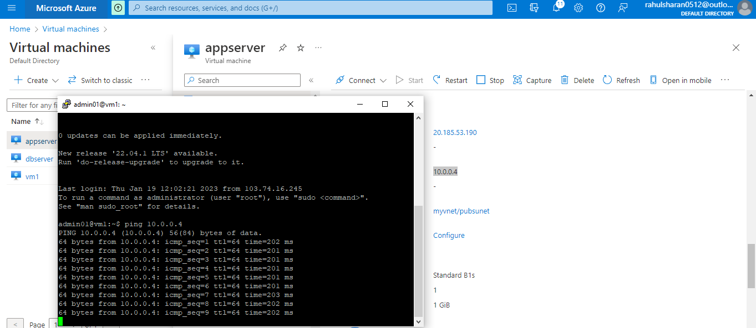

5. Create a private DNS zone and add virtual network link

Created private DNS zone.

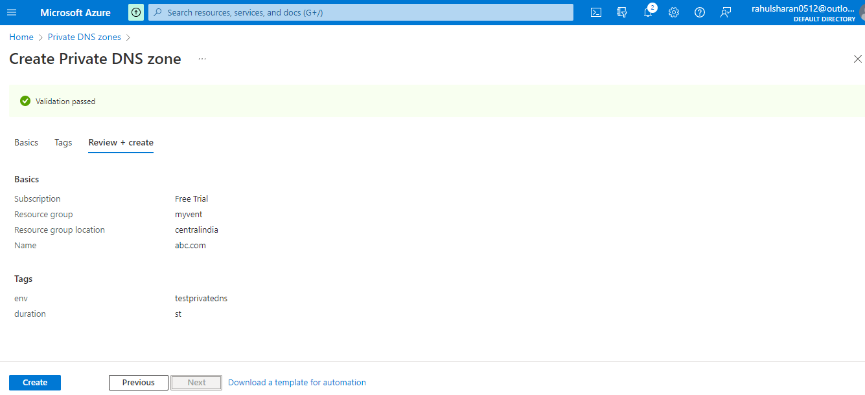

Added virtual network link in private DNS zone.

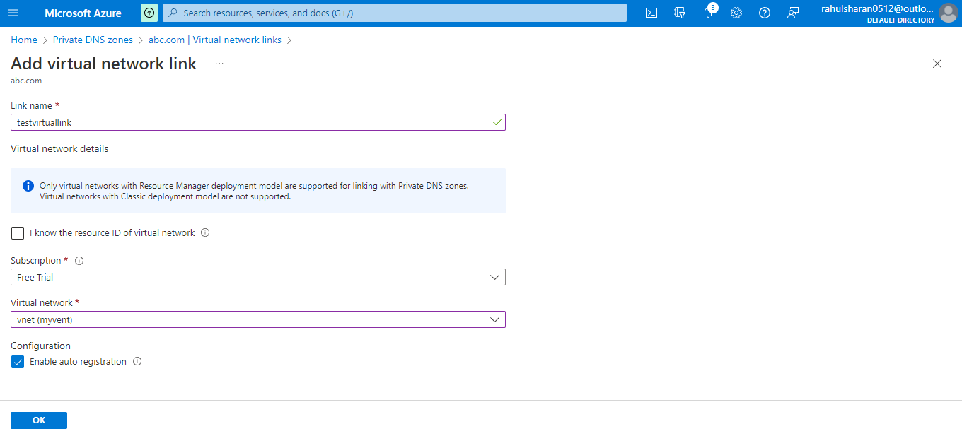

Resolved Domain name to IP address.

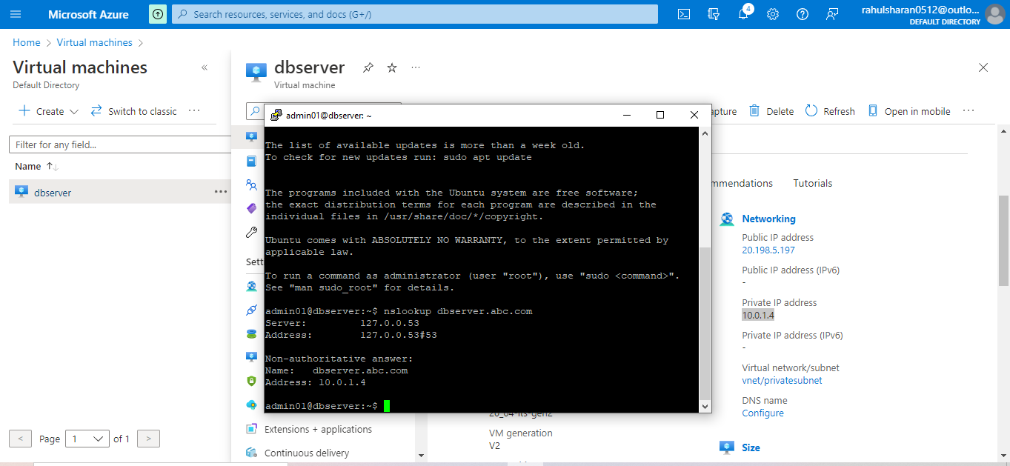

To associated new Public and private IP-address to VM’s.

VM (appserver) ->Networking->Network interface (NIC) ->IP configuration.

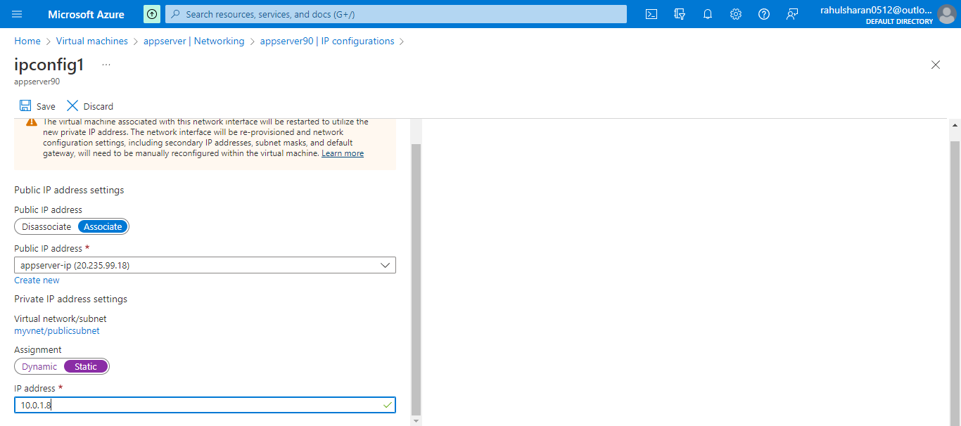

Successfully associated private IP address to VM (appserver).

